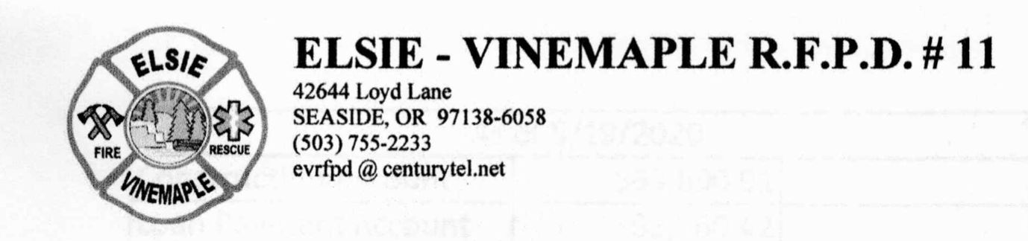

Elsie Vinemaple Fire Protection District (EVRFPD)
Special Board Meeting – Zoom Remote
January 24, 2024, 6:00 p.m.
MINUTES

REMOTE ACCESS: https://us06web.zoom.us/j/87380952313?pwd=nVP4luwWMZaUbPm7XiGRaba9q1PM9c.1

- The meeting was called to order at 6:20 p.m.
- Roll Call. All Board members were present (Carmichael, Hecox, McCann, Morrison, Walsh). Approximately 100 guests joined as well.
NOTE: This zoom meeting only allowed 100 persons at a time. The moderator moved people on as someone dropped out.
- Executive session under ORS 192.660(2)(b) to consider the dismissal or disciplining of, or to hear complaints or charges brought against, a public officer, employee, staff member or individual agent who does not request an open hearing. Note: Executive session was not used since Chief Mike chose a public forum.
This part of the meeting was set for Chief Mike Wammack to make a statement in response to the Board letter given to Mike on January 21. Mike had an option to present his response in the executive session or as part of the public session. Mike chose to use the public session. This part of the meeting was then turned over to Mike who spoke for about 30 minutes.
Mike's presentation emphasized his long service to the Fire District and his efforts to work with the Board on all issues. He emphasized that small volunteer districts such as ours always have tight budgets and not enough funds to adequately address facilities upkeep, especially when our equipment is often second hand. Mike did acknowledge mistakes but did not take responsibility for them or address them in any detail, especially with regards to Station 2.

- Board Discussion and Response. Following Chief Mike’s response, each Board member made a statement. These statements all acknowledged Chief Mike’s many years of effort in the supervision and training of the volunteers in providing needed medical and rescue service to the District. They also noted that the many years of service, combined with the workload the Chief lived, led to increasing problems with administration, operations and especially with the management and supervision of the construction and permitting needed for Station 2, which began as a levy passing in 2016. Those issues led directly to the current situation that Board members had tried to address, only to be met with resistance from Chief Mike.
Board members expressed disappointment that they had not heard Chief Mike acknowledge any responsibility for the mounting problems and concerns resulting from those problems, or offer any willingness to work with the Board to improve the situation. As a result of his consistent and ongoing opposition to the Board’s efforts to do our job per Oregon state statute, the Board was faced with a difficult decision.

Following those statements, a motion was made by Wayne and seconded by Staciy that read: “I move to end the volunteer relationship with Chief Wammack pursuant to the issues outlined in the letter provided to him and after considering his statements at tonight’s meeting. I further move to direct Kerry Walsh to issue a letter to this effect and take any other administrative actions that may be needed to wrap this up.”
This motion passed 5 yes, 0 no.

Following the motion Vivian read a statement to the public, which emphasized:
- Contingency plans are in place to move ahead with different leadership.
- Help is coming from Mist Birkenfeld and Banks, and new volunteers are already stepping up. We hope some of our current volunteers will come back and continue to serve their community with the mission that has always motivated them -- to help others in need.
- We will begin a search for an interim Chief immediately, in coordination with the Special Districts Association of Oregon who has access to retired Chiefs from all over who are willing to help in situations like this. We have been told by our SDAO consultant that we should be able to find someone fairly quickly.
- In the meantime, the Board will take over administrative duties. Current volunteers and new volunteers who have stepped up already will continue training and responding, with the help and support of the neighboring districts.
- Significant change is always uncertain, but we are doing this with the confidence that not only will this best serve our community, but that it will strengthen the level of engagement in our community, and make Elsie Vinemaple a safer place to live.

- Adjourn. Kerry made a motion to adjourn, and Wayne seconded. Motion passed 5 yes, 0 no. The meeting adjourned at 7:14 p.m.

